REVIEW FOR THE FIFTH GRADERS
School year: 2019- 2020
Class:_____________ | Student’s name:____________________________
- Look and write.
Example:  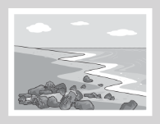  B beach | 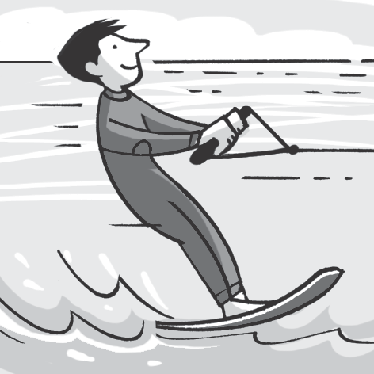  ____________ | 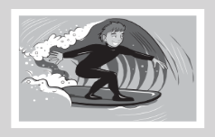  ___________ | 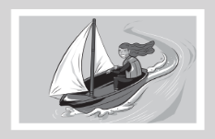  ___________ | 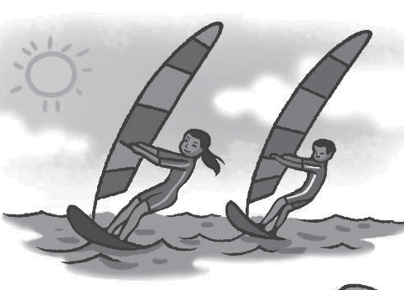  ____________
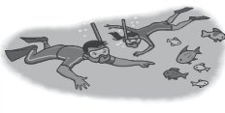  ____________ | 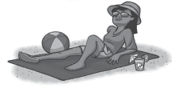  ____________ | 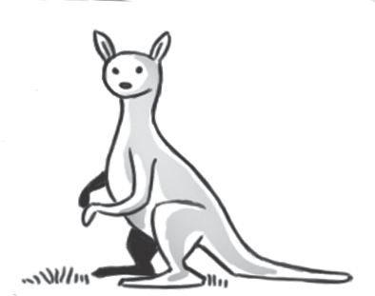  ____________ | 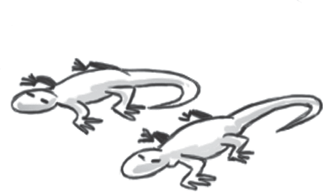  ____________ | 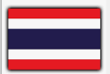  ____________
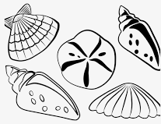  ____________ | 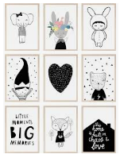  ____________ | 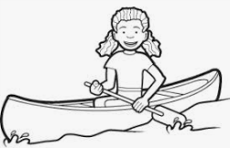  ____________ | 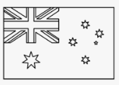  ____________ | ____________
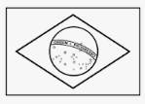  ____________ | ____________ | 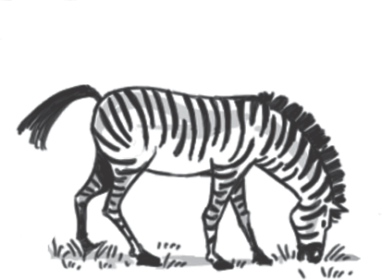  ____________ | ____________ | 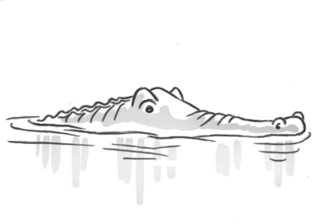  ____________
- Complete the words.
1 pl a y ba s ketball 2 vi it fa ily 3 t_ ke p_otos
4 r ad co ics 5 d_ gym_astics
- Unscramble and write.
Example: I love our apartment. It’s beautiful (ueablifut).
1. We don’t go to that beach. It’s (lolutdep).
2. This is my favorite beach. It’s big and (lenac).
3. Look, that park doesn’t have any flowers. It’s (guyl).
4. That playground is (erandougs). We don’t play there.
- Complete the sentences.
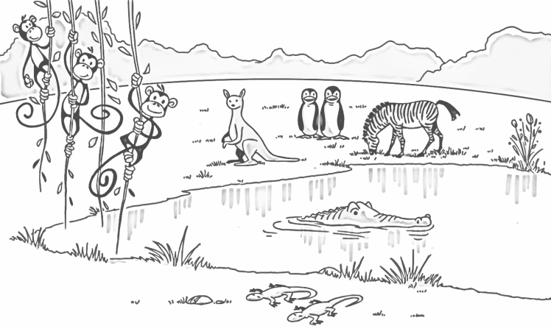
Example: Is the zebra eating? Yes, it is.
1. ____the kangaroo jumping? No,_____________
2. ____the monkeys running? No,_____________
3. Are the lizards climbing? ___, they ___ ____
4. Are the penguins standing? ___, they _______
5. What is the crocodile doing? ________________
- Look and correct the sentences.
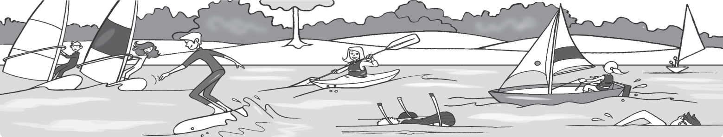
4
5
1
2
3
6

Example: 1. They’re kayaking. They aren’t kayaking. They’re windsurfing.
- He’s swimming.
- They’re sailing.
- She’s snorkeling.
- She’s waterskiing.
- He’s surfing.
- What do they like? Match and write.
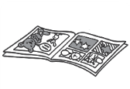
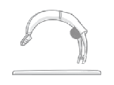
- Emma likes fishing .
1 Emma 2 Jacob 3 Anna 4 Sadie 5 Ben
- Jacob likes ……………………...
- Anna -----------------.
- Sadie ………………………...
- Ben ………………………………………..

- Look and write.
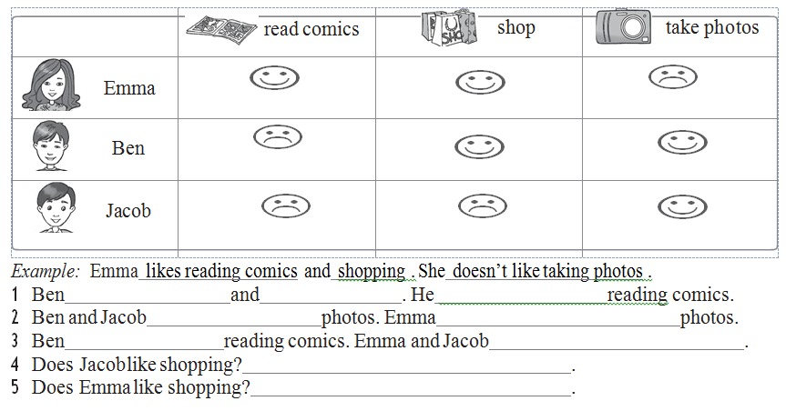

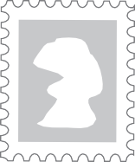
VIII. Read the postcard and answer the questions. Circle A, B, or C.

Hi Clara!
How are you? I’m at the beach on vacation. I’m in Phan Thiet. The weather is sunny and the sea is blue. It’s very clean and beautiful here. I’m wearing my sunglasses and a big hat. I look good! I’m sitting on the beach, reading comics and writing postcards. My sister and brother are swimming in
7836 North Drive
Washington DC 20008
USA
the sea.
Every day on vacation we go swimming in the sea. I like snorkeling and the water isn’t polluted. I can see lots of colorful fish. Yesterday, I saw a dolphin! We are staying here for one week in a hotel. We can eat lots of fish and seafood. I love it here!
From Mi

Example: Who is writing the postcard?
A. Clara is writing the postcard.
B. Mi is writing the postcard.
C. Mrs. Taylor is writing the postcard.
1- Where is Mi?
A She’s on vacation at the beach in Phan Thiet.
B She’s in the sea in Phan Thiet.
C She’s at a seafood restaurant in Phan Thiet.
2- What is Mi doing?
    - She’s swimming and snorkeling in the sea.
    - She’s writing postcards, reading comics and sitting on the beach.
    - She’s eating fish and seafood at a restaurant.
3- How is Phan Thiet?
A The sea is blue but the weather isn't nice.
B The beach is clean, but the sea is polluted.
C The beach and the sea are clean.

